**DAILY ONLINE ACTIVITIES SUMMARY**

|  |  |  |  |  |  |  |
| --- | --- | --- | --- | --- | --- | --- |
| **Date:** | **27/06/2020** | | | **Name:** | **Chandana Patil** | |
| **Sem & Sec** | **6th Sem & A Sec** | | | **USN:** | **4AL17CS020** | |
| **Pre-Placement Training Summary** | | | | | | |
| **Pre placement training** | **9:00 am to 11:00 am – DBMS**  **11:00 am to 1:00pm – JDBC & ODBC** | | | | | |
| **Faculty** | | **1.Mr. Hemanth Kumar**  **2. Mr. Sayeesh** | **Duration** | | | **4 hrs** |
| **Assessment** | | | | | | |
| **Problem Statement:**  **1.** DBMS (Scheme and ER Diagrams) | | | | | | |
| **Status: Completed** | | | | | | |
| **Uploaded the report in GitHub** | | | **Yes** | | | |
| **If yes Repository name** | | | [**https://github.com/chandanapatil/PrePlacement-Training.git**](https://github.com/chandanapatil/PrePlacement-Training.git) | | | |
| **Uploaded the report in slack** | | | **Yes** | | | |

**Training snapshots:**

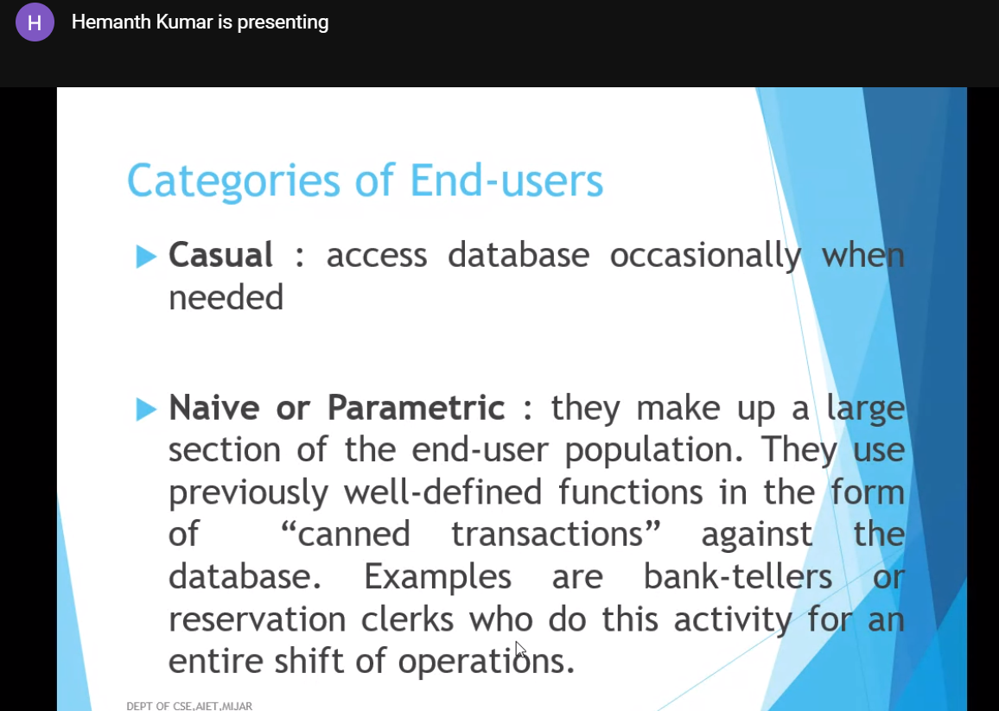

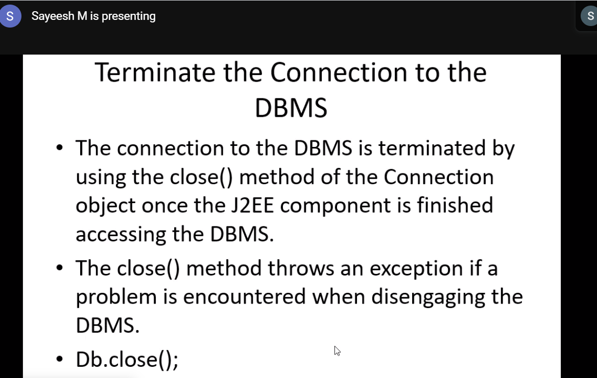

**Assessment:** DBMS (Scheme and ER Diagrams)

**1.**

Student (snum: integer, sname: string, major: string, level: string,age: integer)

Class (name: string, meets at: string, room: string, d: integer)

Enrolled (snum: integer, cname: string)

Faculty (fid: integer, fname: string, deptid: integer)

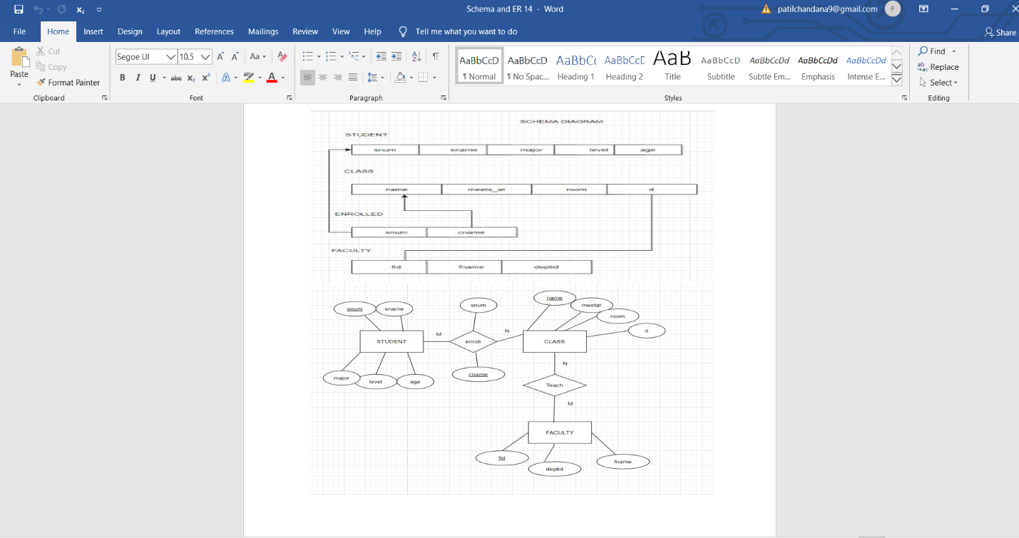

**2.**

BRANCH (branch-name:string,branch-city:string,assets:real)

ACCOUNT (accno:int,branch-name:string,balance:real)

DEPOSITOR (customer-name:string,accno:int)

CUSTOMER (customer-name:string,customer-street:string,city:string)

